

Fall Into the Unknown

Game Development Document

Name: Khoo Zhong Jun
Email: hfyzk4@nottingham.edu.my
GitHub: https://github.com/Repeating1212/Fall-Into-the-Unknown

Fall Into the Unknown
“ Equip – Challenge – Survive – Upgrade ”
A survive action game, providing with various skill and enemies. Defeat waves of enemies, challenge complex creatures, earn victory rewards, and updates game character.

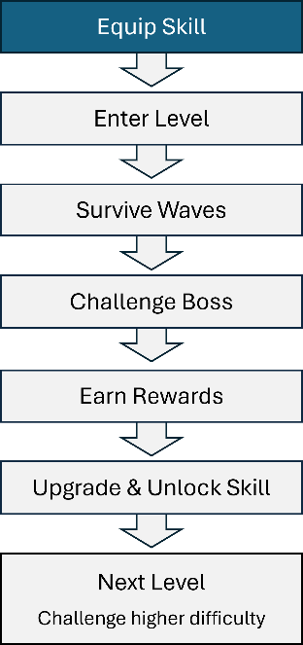 | Start Scene  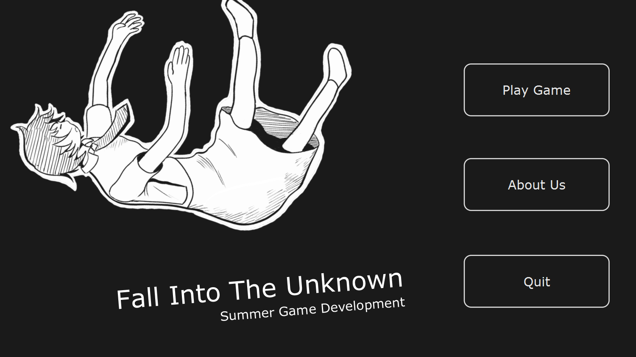

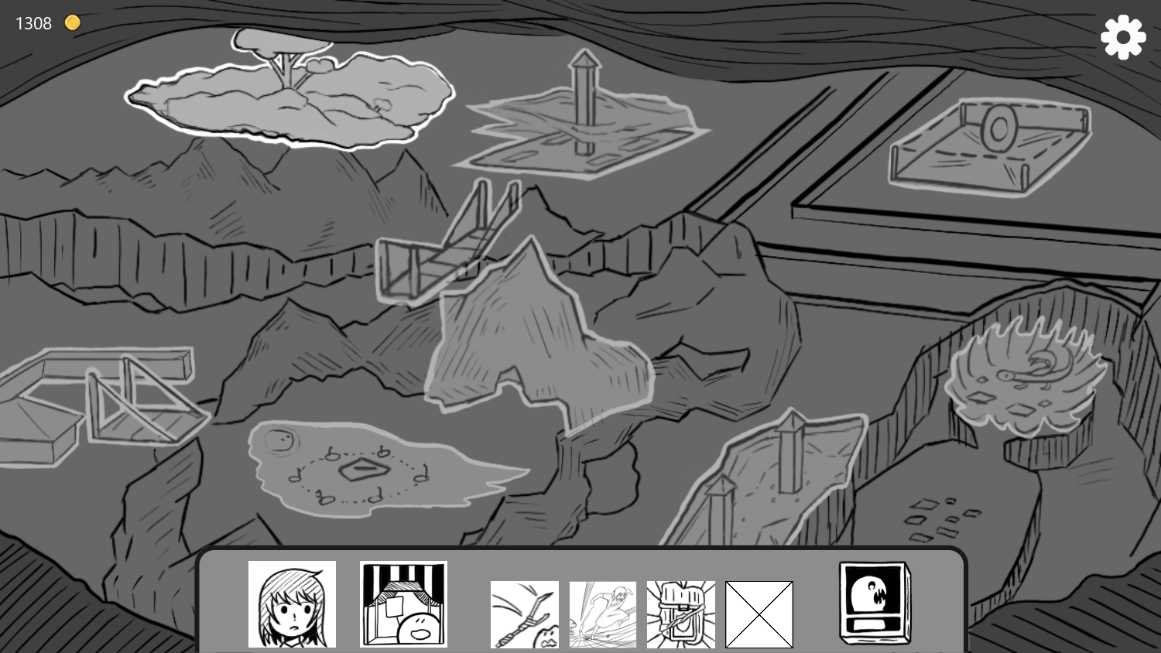 | Game Scene  - Displays map  - Display equipment scene  - Display encyclopaedia  (Haven’t implement)  - Display character scene  (Haven’t implement)

Equipment Scene  Display skills  Handles equip skills  Handle upgrade skills | -  -  -  . | 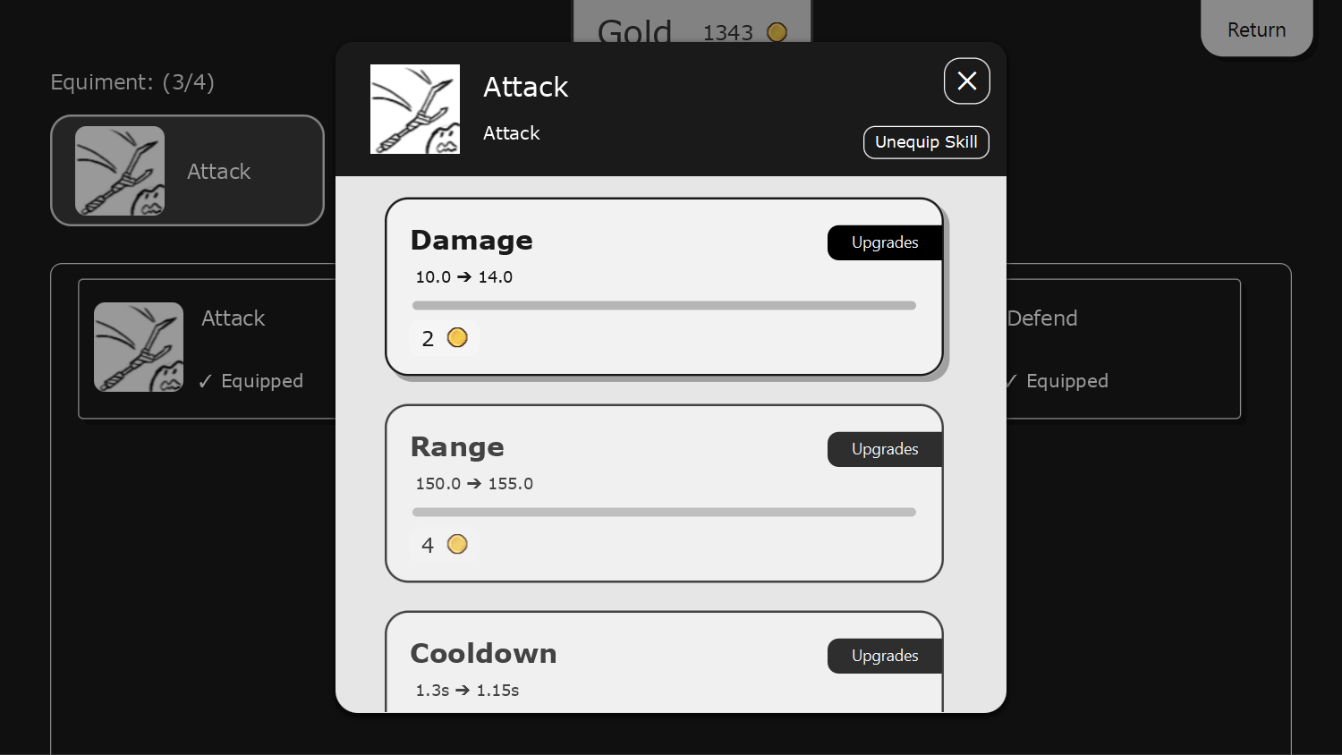

Basic Level Design
Level Sample  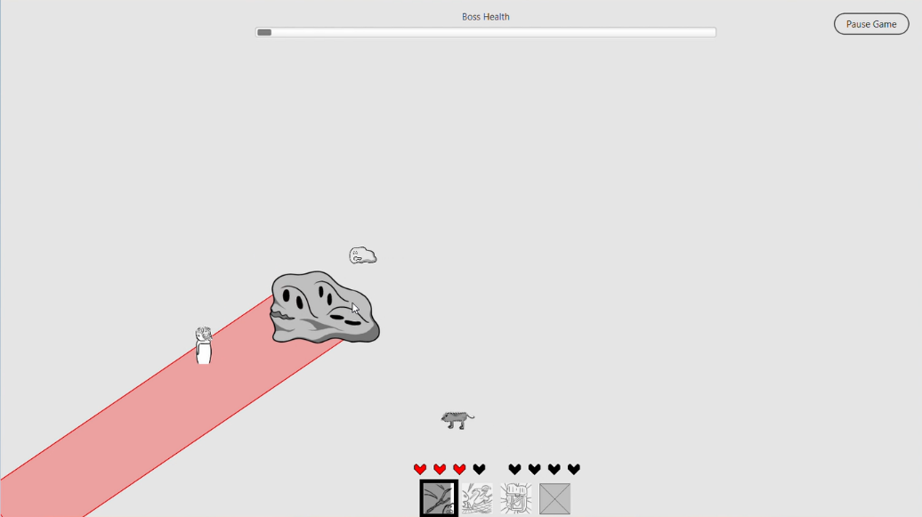 | 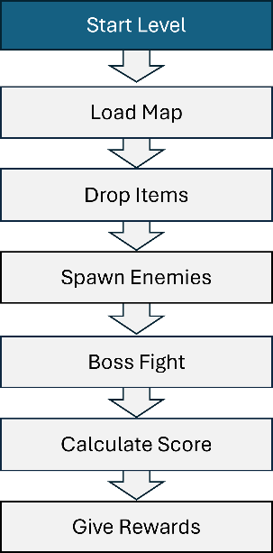

Level Sample Settings:
Enemy  1 | White Slime | Grey Slime | Rat | Slime King (Boss)
Enemy  1 |  |  | 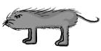 | 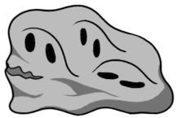
Enemy  1 | Rush toward player | Divide into smaller slime when dead | Move fast  Deal damage when touch | Rush + Spawn slime +  Spawn cone attack area

Wave  1 | Wave 1 | Wave 2 | Wave 3
Wave  1 | Total 5 round:  Map spawn rats, increasingly from 2 to 7. | Total 3 round:  Enemy with total 5 ~ 8, random spawn within white slime, grey slime and rat. | Boss round:  Map spawn Slime King, and continouesly spawn rats in map boundary.

Skill  1 | Slash | Dash | Defend
Skill  1 |  | 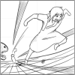 | 
Skill  1 | Damage enemies within a cone area | Flash toward a place | Undamagable for a period
Skill  1 | Upgrades:  Damage, range, cooldown, and angle. | Upgrades:  Cooldown, and range. | Upgrades:  Cooldown, and duration.

Game background:
A girl falls into an unknown area. To find the way back, she needs to pass through different area, fight against unfriendly creatures, so to go to portal and escape from the mysterious place.
** Note that the game background may changes

